- 12pt, double spaced throughout, Times New Roman, including title (no bolding or underlining).
SPECS

- Paragraph Menu: Widow/Orphan control “off” and Spacing: Before and After set to 0 pt.
- Running header (½” from top): Student’s last name and page number, right justified on each page.
Your last name ½” from top, in header, right justified, followed by page number beginning on page 1.

Smyth 1
Jeremy Smyth
Dr. Foster
AP Literature (Block B)
14 February 2020
Title of Paper
Text text text text text text text text text text text text text text text text, text…
1” margins throughout, except running header with your name and page number on each page (see right).
Your name, instructor’s name, course and section, and date (day month year as shown).
TITLE PAGE

Title centered, same font as essay body: 12pt Times New Roman, no bolding or underlining.
New paragraphs indented ½” or one Tab.
Block Quotes: use when quoting 5+ lines of prose or 4+ lines of poetry. Indent the quotation (no quote marks) an extra ½” from left margin only and continue with double spacing. Put page number in parentheses after final punctuation.
1” margins continue throughout paper (note exceptions for block quote and running header).

Smyth 2
…text text text text:
Quote quote quote quote…
quote quote quote quote. (15)
CONSECUTIVE
PAGES

Alphabetize your list by first letter of entry. Double space throughout with hanging indentation (i.e. lines after first line of an entry are indented ½”).
2+ sources by the same author:
order alphabetically by title, and use three hyphens in place of the author’s name for every entry after the first.

Smyth 6
Works Cited
Lewis, C. S. Mere Christianity. HarperCollins, 2001.
---. Reflections on the Psalms. Harcourt, Brace, 1958.
“Morrill Land Grant Act of 1862.” Prairie View A&M, 2003. https://www.pvamu.edu/library/ about-the-library/history-of-the- library-at-prairie-view/1890-land-grant-history/. Accessed 6 Dec. 2008.
Works Cited begins on a new page. Center title without bolding, underlining, or italicizing.
WORKS CITED
Title of an article is placed in quotation marks and the title of its “container” (in this case, a host website) is italicized and followed by a comma and the date of publication. For online sources, also include the URL (when possible), and date accessed.

WORKS CITED
Elements of citation entries should be listed in the following order with the punctuation shown:
Author. Title of Source. Title of Container, Other Contributors, Version, Number, Publisher, Publication Date, Location.
Note: Location refers to the pages of an essay, article or poem in a larger work, the location of a physical object, or the URL of an online source.

IN-TEXT CITATIONS
- Required for every kind of borrowing, including quotations, facts, and paraphrased ideas.
- Not needed for common knowledge, familiar proverbs, or well-known quotations.
- Point readers to the source’s entry in your Works Cited list (usually an author’s last name) while creating the least possible disruption in your text.
Examples:
According to Smith, reading is “just half of literacy. The other half is writing” (195).
or
Reading is “just half of literacy. The other half is writing” (Smith 195).
PRINT with ONE AUTHOR
IN-TEXT: One claim is that, “quote, quote, quote, quote” (Smith 195). OR
IN-TEXT: According to Smith, “quote, quote, quote, quote” (195).
Same Author with Multiple Works, put shortened titles in parentheses, with article titles in quotation marks: (Smith “Too Soon” 38); and book titles italicized: (Smith Write to Learn 6).
WORKS CITED BOOK:
Author Last Name, First Name. Book Title. Publisher, Year Published.
WORKS CITED ARTICLE:
Author Last Name, First Name. “Article Title.” Periodical Title., vol. __, no. __, Month Year, pp. __-__.
(Note: “pp.” is for more than one page and “p.” if article appears on only one page in the periodical.)
PRINT with MULTIPLE AUTHORS
2 Authors
IN-TEXT 2 AUTHORS: (Best and Marcus 9).
WORKS CITED BOOK 2 AUTHORS: Last Name, First Name and First Name Last Name. Title. Publisher, Year Published.
WORKS CITED ARTICLE 2 AUTHORS: Last Name, First Name and First Name Last Name. “Article Title.” Periodical Title., vol. __, no. __, Month Year, pp. __-__.
IN-TEXT 3+ AUTHORS: (Best et al. 9).
3+ Authors
WORKS CITED BOOK 3+ AUTHORS: Last Name, First Name, et al. Title. Publisher, Year Published.
WORKS CITED ARTICLE 3+ AUTHORS: Last Name, First Name, et al. “Article Title.” Periodical Title., vol. __, no. __, Month Year, pp. __-__.
NO AUTHOR GIVEN
IN-TEXT for BOOK: (Reasons 9). An italicized short form of the title is used for books, plays, films, or websites.
IN-TEXT for ARTICLE: (“Believing is Knowing” 3). Quotation marks are used around a short form of the title.
WORKS CITED BOOK: Book Title. Publisher, Year Published.
WORKS CITED ARTICLE: “Article Title.” Periodical Title., vol. __, no. __, Month Year, pp. __-__.
CORPORATE AUTHOR
IN-TEXT: (Modern Language Association 68).
WORKS CITED BOOK: Modern Language Association. Book Title. Publisher, Year Published.
ANTHOLOGIES: ESSAYS, STORIES OR POETRY IN A COLLECTION
ESSAY OR STORY WITH NAME IN YOUR TEXT: (page number). E.g. Augustine wrote “text, text” (27).
NAME IN CITATION: (Name page number). E.g. One famous theologian wrote “text, text” (Augustine 27).
POETRY WITH WRITER’S NAME IN ESSAY TEXT: (Book.Canto.Lines). E.g. (3.1.34). WRITER’S NAME IN CITATION (Name Lines).
Note: if only line numbers are given, provide (Line Numbers), if no canto, provide (Book Number.Line Numbers), etc.
QUOTING POETRY: a forward slash with a space on each side ( / ) is placed to indicate line breaks (except in block quotations, in which case the poet’s formatting should be shown). Stanza breaks are indicated with two slashes ( // ). Include line numbers in your citation. For long poems, such as epics, write the canto or book number in Arabic numerals, before line numbers.
Example: The speaker of the poem argues that death gives no time to waste: “But at my back I always hear / Time’s wingèd chariot hurrying near (21-22).
WORKS CITED: Last Name, First Name. “Essay/Story/Poem Title.” Collection Title, edited by First Name Last Name, Publisher, Year Published, p. __. (Enter page that the work appears on. For multi-page works use “pp.”)
ARTICLE FROM A DATABASE
IN-TEXT: (Last Name 3).
WORKS CITED: Author Last Name, First Name. “Article title.” Journal or Source Title, vol. _, no. _, Year Published, pp. __-__. Database Name, url or DOI (Digital Object Identifier, e.g. Gale Document Number.
BIBLE
The version is included (italicized) in the first in-text citation, followed by book, chapter and verse.
IN-TEXT: (Version, Book chapter.verse). Example: (New International Version, John 1.14).
WORKS CITED: The Bible. Version Name, Publisher, Year Published.
BIBLE COMMENTARY
IN-TEXT: (Commentator Last Name page). Example: (Barton 14).
WORKS CITED: Author Last Name, First Name. Volume Name. Publisher, Year Published. Series Title volume#.
Example: Barton, Bruce. Matthew. Tyndale House Publishers, 1996. Life Application Bible Commentary 1.
CLASSICS WITH MULTIPLE EDITIONS
Page numbers are given for the version being cited, followed by a semicolon and then appropriate abbreviation for volume (vol.), book (bk.), part (pt.), chapter (ch.), section (sec.), or paragraph (par.).
IN-TEXT: Text, text, text, text (79; ch. 1).
WORKS CITED: Author Last Name, First Name. Book Title. Publisher, Year Published.
INDIRECT SOURCES
IN-TEXT: (qtd. in Name 14).
WORKS CITED: Author Last Name, First Name. Book Title. Publisher, Year Published.
INTERVIEW
IN-TEXT: (Interviewee Last Name).
WORKS CITED: Interviewee Last Name, First Name. Personal Interview. Day Month Year.
LECTURE or SPEECH
IN-TEXT: (Last Name).
WORKS CITED: Speaker’s Last Name, First Name. “Title of Speech.” (if any) Conference Title, Name of Organization, Date, Venue, City, State. Descriptor.
Example: Stein, Bob. “Reading and Writing in the Digital Era.” Discovering Digital Dimensions, Computers and Writing Conference, 23 May 2003, Union Club Hotel, West Lafayette, IN. Keynote Address.
MULTIVOLUME WORKS
If you cite from only one volume throughout your paper, provide only the page number as with a regular book and include the volume number in works cited. If you cite from different volumes of a multivolume work, include volume number and page numbers in citation.
IN-TEXT WHEN ONE VOLUME CITED: …as Quintilian wrote in Institutio Oratoria (14-17).
IN-TEXT WHEN 2+ VOLUMES CITED: …as Quintilian wrote in Institutio Oratoria (1: 14-17).
WORKS CITED WHEN ONLY ONE VOLUME USED: Author Last Name, First Name. Book Title. Vol. 5, Publisher, Year Published.
WORKS CITED WHEN 2+ VOLUMES USED: Last Name, First Name, general editor (if applicable). Set Title. Publisher, Year(s) Published. __ vols. (enter the total # of volumes in the set)
PLAYS
If your quotation takes up four lines or less in your paper and is spoken by only one character, use quotation marks and run it in the text of your essay. Use arabic numerals unless your instructor prefers roman numerals.
Example: Two attendants watch as Lady Macbeth struggles with her guilt: “Here the smell of blood still. All the perfumes of Arabia will not sweeten this little hand” (5.1.50-51).
IN-TEXT: (Act Number. Scene Number. Line Numbers). E.g. (5.1.50-51).
Note: if only line numbers are given, provide (Line Numbers), if no Act, provide (Scene Number. Line Numbers), etc.
WORKS CITED: Last Name, First Name. Play Title. Translated by First Name Last Name, Publisher, Year Published.

REFERENCE BOOKS (e.g. Dictionary or Encyclopedia)
IN-TEXT: (Word/Entry Heading).
Example: According to the Oxford English Dictionary, the word “defeat” … (“Defeat”).
WORKS CITED for Print Source: “Word.” Reference Book Title. Edition, Year Published.
WORKS CITED for Online Source: “Entry Word/Heading.” Dictionary Name, Publisher, Year Published. Name of Website, entry url. Access Date. (access date optional)
SONG
IN-TEXT: (Artist).
WORKS CITED: Artist. “Song Title.” Album Title, Year, track. Streaming Service, URL for song.
TABLES AND IMAGES
Tables and images should be placed as close as possible to the relevant text. Tables are labeled Table, given an Arabic numeral and a title. Images (e.g. photo, map, graph, chart) should be labeled Figure (abbreviated Fig.), assigned an Arabic numeral and given a caption. Double space all notes. If the caption provides complete source information, and the work is not cited elsewhere, no entry in the works cited is needed.
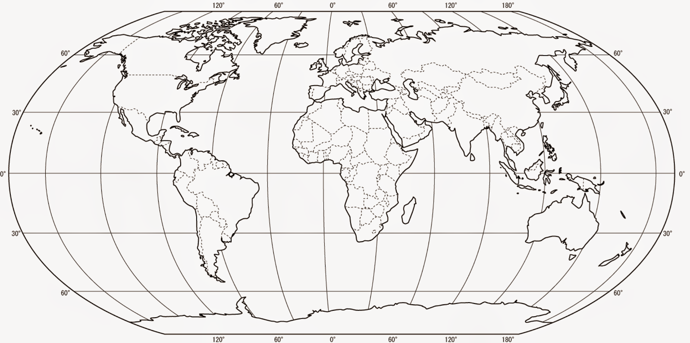
Fig. 1. Creator’s First Name Last Name. “Image Title.” Source Title. Publisher, Year Published.
Table 1ª
Table Title
Year | Bachelor’s  Degrees | Master’s  Degrees | Doctor’s  Degrees
1996-97 | 12,345 | 2,345 | 345
1997-98 | 2,345 | 3,456 | 456

Source: First Last Name of Creator. Title of Source. Publisher, Year Pub.
- Notes by essay writer…

WORKS CITED FOR IMAGE TAKEN FROM A BOOK:
Artist Last Name, First Name. Title of Work. Year Created, Location of Original, City. Book Title, Author First Name Last Name, Publisher, p. __.
WORKS CITED FOR ARTWORK TAKEN FROM A WEBSITE (e.g. Painting, Sculpture, Photograph):
Creator’s Last Name, First Name. Title of Piece. Year Created. Institution Where Piece is Housed, City. Website Title, URL. Accessed Day Month Year.
WORKS CITED FOR A WEB-BASED IMAGE (i.e. no known physical piece): Creator’s Last Name, First Name. “Title of Digital Image.” Title of Website, Publisher, Publication Date, URL.
TIME-BASED MEDIA (Videos, Podcasts, etc.)
IN-TEXT: (Short Form of Title 00:02:15-00:02:35). Include the range of hours, minutes and seconds referenced.
WORKS CITED: Title. Directed by First Last Name, Film Studio or Distributor, Release Year.
WORKS CITED FOR WEB SOURCED MEDIA (e.g. YouTube). Last Name, First Name. “Video title.” Video Site Name, uploaded by Name, Date Published, video url.
Note: If uploader and creator are the same, only include the name once and start with the video title, otherwise, start with the creator’s name.
WEBSITES
SIGNAL PHRASE IN ESSAY TEXT: no in-text citation needed. Example: According to cnn.com, “text, text, text.”
SIGNAL PHRASE IN CITATION: (Name or Signal Phrase). Note: no paragraph number is needed.
WORKS CITED: Last Name, First Name. “Article Title.” Website Name, Date Electronically Published. URL.
WORKS CITED NO AUTHOR: “Article Title.” Website Name, Date Electronically Published. URL.

12/7/16

